*Bank Direct Marketing Campaign Analysis Report*

*Wireframe Documentation*

# Home page

Page-1

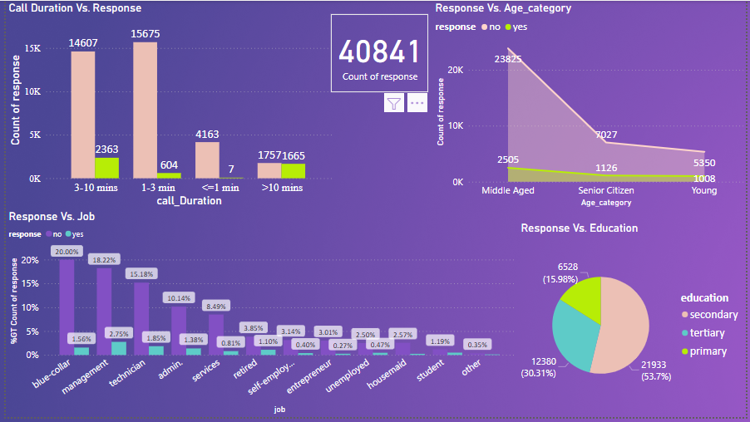

Page-2

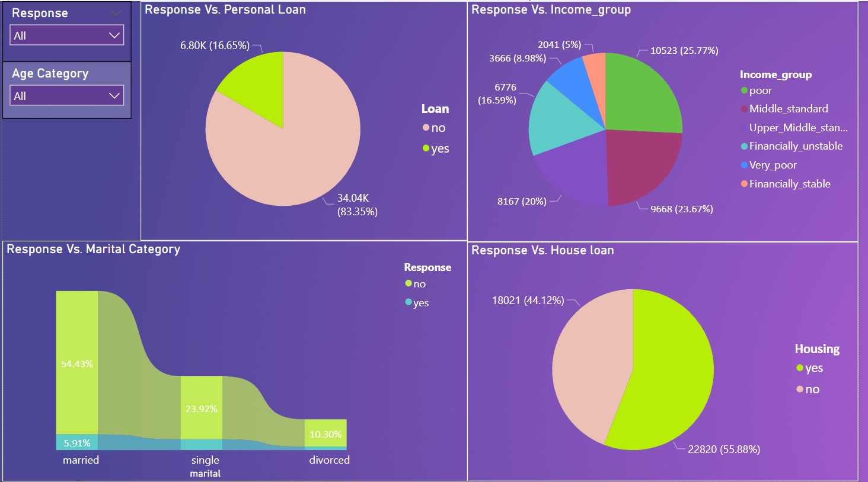

Page-3

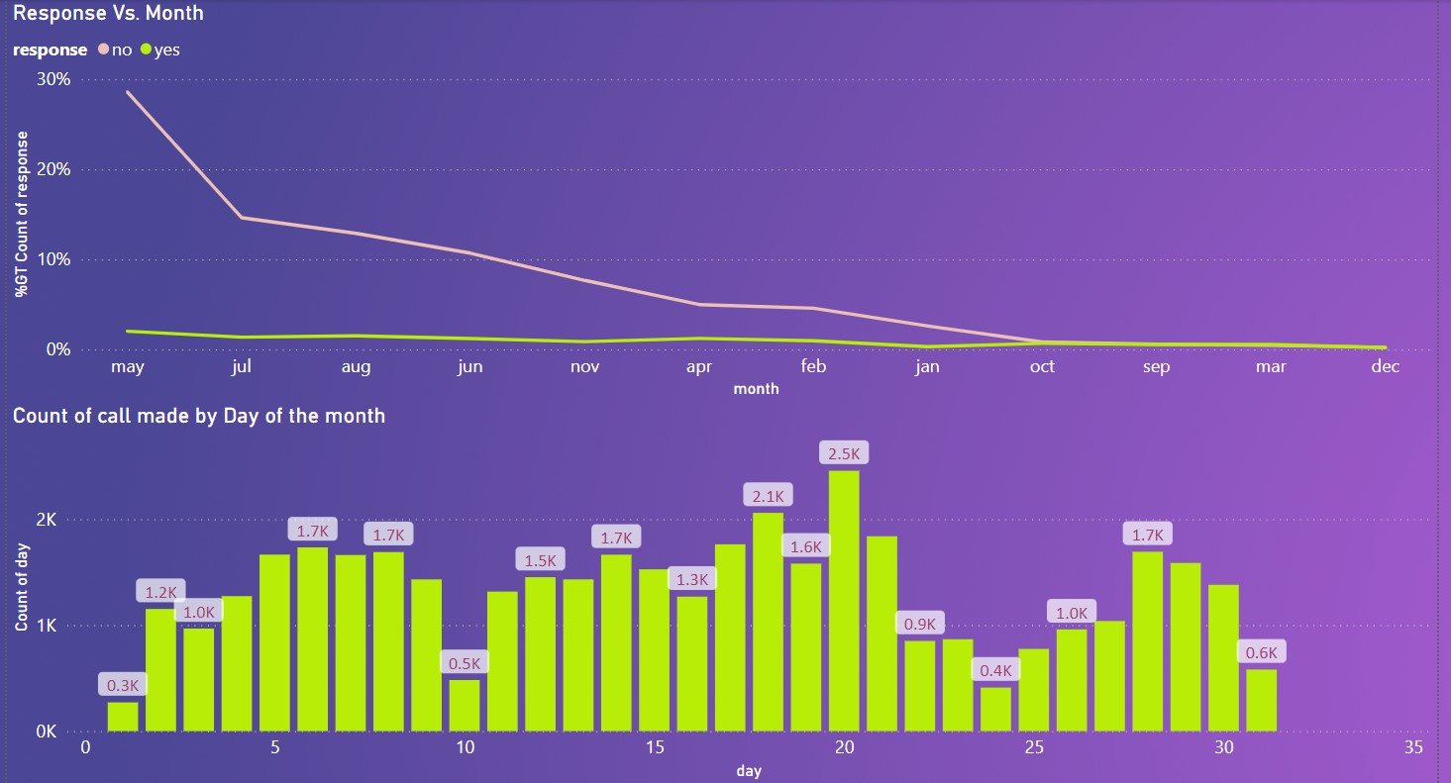

## Analysis of Age:

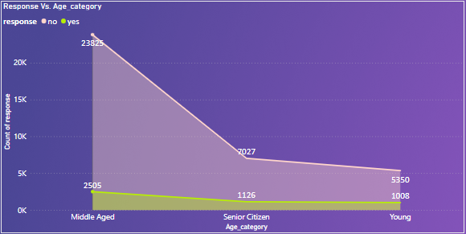

In case of response “No”, 70 yrs.+ is considered outlier, while for “Yes” it is not. So the average age for “Yes” group is higher. Among which most calls are made to the middle aged i.e. between 31-51 yrs. old.

If we see the success rate from the above graph the young age category people has highest success rate, followed by senior citizen and middle aged.

## Analysis of Day:

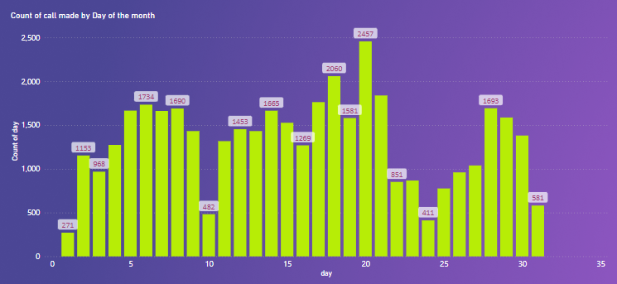

Most of the calls made during 14-21st of the Month, and then some between 5-8th and some during 28-30th of the month. This can be explained by Initial calling after receiving salary at the beginning (5-8th) of the Month. Then to follow up after a cooling period of 2 weeks and then at the end of the month if people are looking to invest their monthly savings.

## Analysis of Job Category Vs. Response:

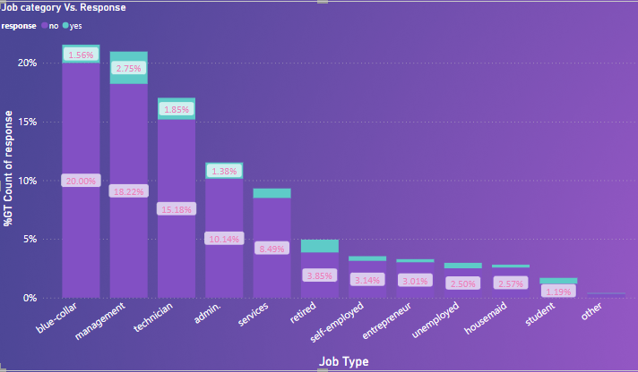

From the above graph it is evident that there are more customers from blue-collar, management, technician and admin. If we see the positive response percentage then management, technician and blue collar people are more likely to go for a term deposit.

## Analysis of Marital status vs. Response:

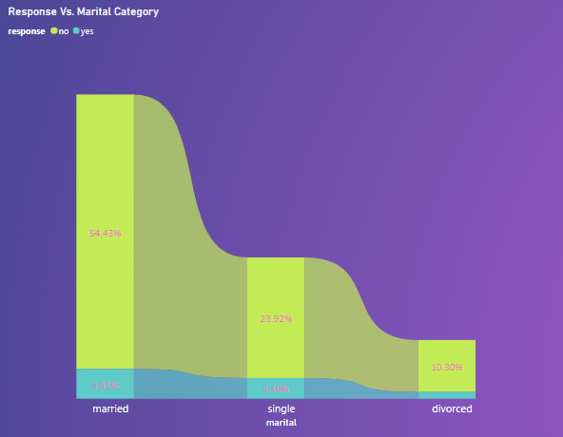

Most of the contacts made during this campaign are with married couple.

## Analysis of Financial Category Vs. Response:

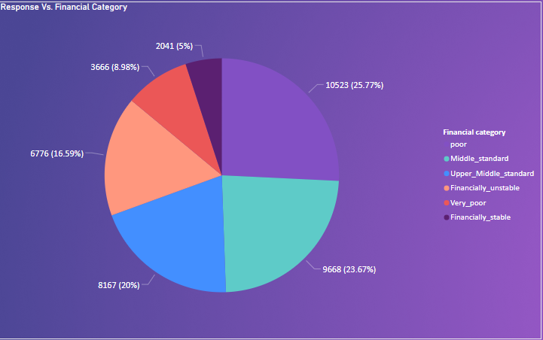

Here, the dataset was divided into groups based on the amount of money in each person's account.

1. 0-70 ->(Very poor)
2. 71-450 -> (poor)
3. 451-1335 -> (middle standard)
4. 1336-4860 -> (upper middle standard)
5. 4861-1000 -> (Rich)

The above pie chart depicts during this campaign most of the call made to poor, middle standard and upper middle standard.

## Analysis of Response Vs. Call Duration:

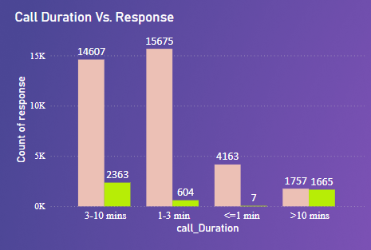

Converting call duration from sec to minutes gives a better idea and better visualization. So, we see that longer calls during last contact are more likely to get converted, indicating they have taken time to understand about the product from the calling agents.

It is observed that success rate is higher in longer duration calls (>10mins), because the customer has taken his/her time to understand the product.

## Analysis of Loan Vs response:

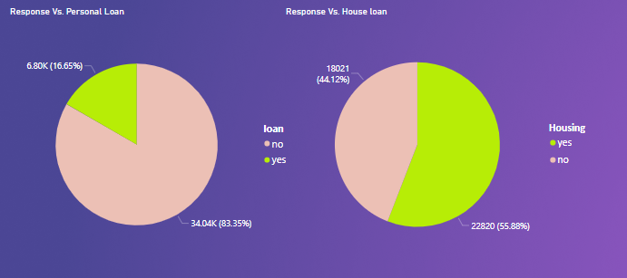

There is a significant impact of loan type upon the term deposit. As we can see the persons having a house loan are more interested for a tern deposit than the persons having personal loan.

## Education Type vs response:

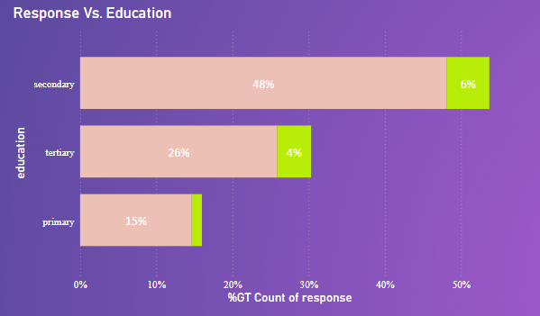

Most of the people are from secondary education category i.e. up to 54% followed by tertiary education category.